The Bull Trout
Facts:
The Bull Trout is Alberta’s provincial fish.
The Bull Trout were one of the main sources of food for the Blackfoot People.
Bull Trout live in cold, clear and clean mountain streams.
The Bull Trout is threatened in much of it’s traditional range.

Why they are threatened:
The Bull Trout are considered Threatened because of over fishing and changes to their habitat. Bull trout habitats are affected by natural gas exploration and through the building of gas and oil pipelines. Global warming has also raised the temperature of many of the cold mountain streams, which has cut their natural habitats in half.
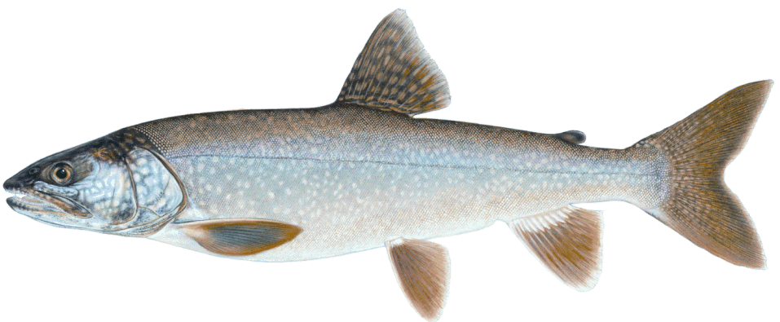

Component | Mark
Title for the Poster | 1 2 3 4
Photo of the Animal | 1 2 3 4
3 facts about the Animal | 1 2 3 4  1 2 3 4  1 2 3 4
Why is it endangered, threatened, or at risk? | 1 2 3 4
Neatness | 1 2 3 4
Grammar and Spelling | 1 2 3 4

Component | Mark
Title for the Poster | 1 2 3 4
Photo of the Animal | 1 2 3 4
3 facts about the Animal | 1 2 3 4  1 2 3 4  1 2 3 4
Why is it endangered, threatened, or at risk? | 1 2 3 4
Neatness | 1 2 3 4
Grammar and Spelling | 1 2 3 4

Component | Mark
Title for the Poster | 1 2 3 4
Photo of the Animal | 1 2 3 4
3 facts about the Animal | 1 2 3 4  1 2 3 4  1 2 3 4
Why is it endangered, threatened, or at risk? | 1 2 3 4
Neatness | 1 2 3 4
Grammar and Spelling | 1 2 3 4

Component | Mark
Title for the Poster | 1 2 3 4
Photo of the Animal | 1 2 3 4
3 facts about the Animal | 1 2 3 4  1 2 3 4  1 2 3 4
Why is it endangered, threatened, or at risk? | 1 2 3 4
Neatness | 1 2 3 4
Grammar and Spelling | 1 2 3 4

